Genetic Algorithms
Section #9

Feature Selection using Genetic Algorithms in Machine Learning

Objective
In this lab, students will:
- Understand supervised learning tasks:
  - Regression
  - Classification
- Learn the importance of Feature Selection
- Apply Genetic Algorithms (GA) to improve model performance
- Evaluate models before and after feature selection

Background
Machine learning models often suffer when:
- Too many irrelevant features exist
- Features add noise instead of useful information
This leads to:
- Lower accuracy
- Overfitting
- Slower training

Solution: Feature Selection
We aim to:
Select the most useful subset of features
Instead of:
Using all features blindly ❌

Why Genetic Algorithm?
Because:
- Feature selection = combinatorial problem
- GA can efficiently search large spaces
Representation (Genotype)
Each chromosome is:
[1, 0, 1, 1, 0, 0, 1]
Where:
- 1 → feature selected
- 0 → feature ignored

Fitness Function
We evaluate:
Fitness = Model Performance (Accuracy or R²)

Part 1: Regression (Friedman-1 Dataset)

Step 1: Import Libraries
import numpy as np
import random
from sklearn.datasets import make_friedman1
from sklearn.model_selection import train_test_split
from sklearn.linear_model import LinearRegression
from sklearn.metrics import r2_score

Step 2: Generate Dataset
X, y = make_friedman1(n_samples=200, n_features=10, noise=0.1)

X_train, X_test, y_train, y_test = train_test_split(X, y, test_size=0.3)
NUM_FEATURES = X.shape[1]

Step 3: Create Individual

def create_individual():
return [random.randint(0, 1) for _ in range(NUM_FEATURES)]

Step 4: Fitness Function
def fitness(individual):
if sum(individual) == 0:
return -1

selected = [i for i in range(NUM_FEATURES) if individual[i] == 1]

model = LinearRegression()
model.fit(X_train[:, selected], y_train)

preds = model.predict(X_test[:, selected])
return r2_score(y_test, preds)

Step 5: GA Operators
def select(pop):
return max(random.sample(pop, 3), key=fitness)

def crossover(p1, p2):
point = random.randint(1, NUM_FEATURES-1)
return p1[:point] + p2[point:]

def mutate(ind):
if random.random() < 0.3:
i = random.randint(0, NUM_FEATURES-1)
ind[i] = 1 - ind[i]
return ind

Step 6: Run GA

def run_ga():
pop = [create_individual() for _ in range(20)]

for gen in range(30):
new_pop = []

for _ in range(len(pop)):
p1 = select(pop)
p2 = select(pop)

child = crossover(p1, p2)
child = mutate(child)

new_pop.append(child)

pop = new_pop

best = max(pop, key=fitness)
print(f"Gen {gen}, R2: {fitness(best):.4f}")

return best

Step 7: Run

best_features = run_ga()
print("Selected Features:", best_features)

Part 2: Classification (Zoo Dataset)

Step 1: Load Dataset

from sklearn.datasets import load_iris
from sklearn.ensemble import RandomForestClassifier
from sklearn.metrics import accuracy_score

data = load_iris()
X = data.data
y = data.target

X_train, X_test, y_train, y_test = train_test_split(X, y, test_size=0.3)
NUM_FEATURES = X.shape[1]

Step 2: Fitness Function
def fitness(individual):
if sum(individual) == 0:
return 0

selected = [i for i in range(NUM_FEATURES) if individual[i] == 1]

model = RandomForestClassifier()
model.fit(X_train[:, selected], y_train)

preds = model.predict(X_test[:, selected])
return accuracy_score(y_test, preds)

Step 3: Run GA (reuse same GA)

best_features = run_ga()
print("Best Feature Mask:", best_features)

Expected Results
- Reduced number of features
- Improved or similar performance
- Faster training
Lab implementation:

Imports
import numpy as np
import random
import matplotlib.pyplot as plt

from sklearn.datasets import make_friedman1, load_iris
from sklearn.model_selection import train_test_split
from sklearn.linear_model import LinearRegression
from sklearn.ensemble import RandomForestClassifier
from sklearn.metrics import r2_score, accuracy_score

Common GA Functions
NUM_FEATURES = None
X_train, X_test, y_train, y_test = None, None, None, None

Create Individual
def create_individual():
return [random.randint(0, 1) for _ in range(NUM_FEATURES)]

Selection
def select(pop):
return max(random.sample(pop, 3), key=fitness)

Crossover
def crossover(p1, p2):
point = random.randint(1, NUM_FEATURES - 1)
return p1[:point] + p2[point:]

Mutation
def mutate(ind):
if random.random() < 0.3:
i = random.randint(0, NUM_FEATURES - 1)
ind[i] = 1 - ind[i]
return ind

REGRESSION PART (Friedman Dataset)
X, y = make_friedman1(n_samples=200, n_features=10, noise=0.1)

X_train, X_test, y_train, y_test = train_test_split(X, y, test_size=0.3)

NUM_FEATURES = X.shape[1]

Fitness Function (Regression)
def fitness(individual):
if sum(individual) == 0:
return -1

selected = [i for i in range(NUM_FEATURES) if individual[i] == 1]

model = LinearRegression()
model.fit(X_train[:, selected], y_train)

preds = model.predict(X_test[:, selected])
return r2_score(y_test, preds)

GA Runner
def run_ga():
pop = [create_individual() for _ in range(20)]

for gen in range(30):
new_pop = []

for _ in range(len(pop)):
p1 = select(pop)
p2 = select(pop)

child = crossover(p1, p2)
child = mutate(child)

new_pop.append(child)

pop = new_pop

best = max(pop, key=fitness)
print(f"Gen {gen}, Fitness: {fitness(best):.4f}")

return best

Run GA (Regression)
best_features_reg = run_ga()
print("Best Features (Regression):", best_features_reg)

Feature Visualization
def plot_feature_selection(mask):
plt.figure(figsize=(10,4))
plt.bar([f"F{i}" for i in range(len(mask))], mask)
plt.title("Selected Features (Regression)")
plt.ylim(0, 1)
plt.show()

plot_feature_selection(best_features_reg)

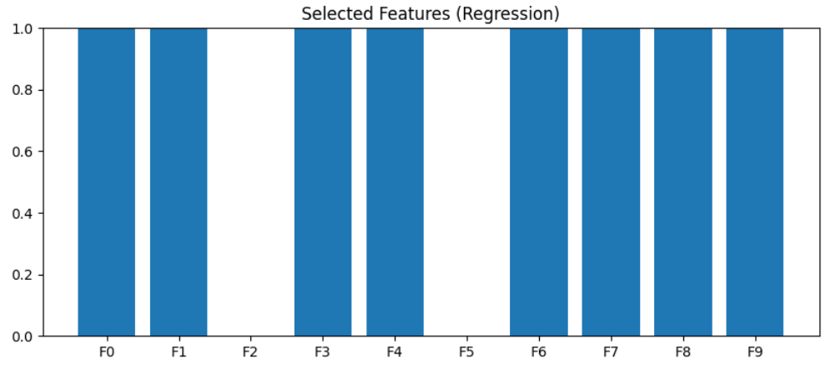
Before vs After (Regression)
# Full model
model_full = LinearRegression()
model_full.fit(X_train, y_train)
pred_full = model_full.predict(X_test)
r2_full = r2_score(y_test, pred_full)

# GA model
selected = [i for i in range(NUM_FEATURES) if best_features_reg[i] == 1]

model_ga = LinearRegression()
model_ga.fit(X_train[:, selected], y_train)
pred_ga = model_ga.predict(X_test[:, selected])
r2_ga = r2_score(y_test, pred_ga)

# Plot
plt.bar(["All Features", "GA Selected"], [r2_full, r2_ga])
plt.title("R² Comparison (Regression)")
plt.show()

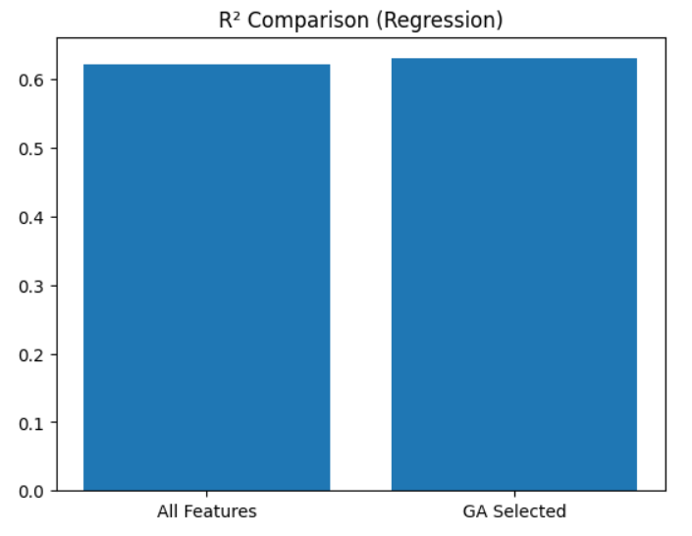

Part 2 Classification

IRIS Dataset
data = load_iris()
X = data.data
y = data.target

X_train, X_test, y_train, y_test = train_test_split(X, y, test_size=0.3)

NUM_FEATURES = X.shape[1]

Fitness Function (Classification)
def fitness(individual):
if sum(individual) == 0:
return 0

selected = [i for i in range(NUM_FEATURES) if individual[i] == 1]

model = RandomForestClassifier()
model.fit(X_train[:, selected], y_train)

preds = model.predict(X_test[:, selected])
return accuracy_score(y_test, preds)

Run GA

best_features_cls = run_ga()
print("Best Features (Classification):", best_features_cls)

Before vs After (Classification)

# Full model
model_full = RandomForestClassifier()
model_full.fit(X_train, y_train)
pred_full = model_full.predict(X_test)
acc_full = accuracy_score(y_test, pred_full)

# GA model
selected = [i for i in range(NUM_FEATURES) if best_features_cls[i] == 1]

model_ga = RandomForestClassifier()
model_ga.fit(X_train[:, selected], y_train)
pred_ga = model_ga.predict(X_test[:, selected])
acc_ga = accuracy_score(y_test, pred_ga)

# Plot
plt.bar(["All Features", "GA Selected"], [acc_full, acc_ga])
plt.title("Accuracy Comparison (Classification)")
plt.show()
